Amendment C229
Boroondara Planning Scheme Update
Fact Sheet July 2016

What is Council proposing?
Amendment C229 proposes to update the Local Planning Policy Framework (LPPF) including:
- introduction of a revised Municipal Strategic Statement (MSS);
- changes to local planning policies including the integration of some policy guidelines into the MSS; and
- removal of redundant local planning policies.
Council is also proposing to make administrative and other minor changes to zones and overlays as a result of updates to the LPPF.
What is a Municipal Strategic Statement and what does it do?
The MSS sets out Council’s broad land use and development vision and forms part of the Boroondara Planning Scheme. It typically identifies the important land use issues in a municipality and articulates objectives to respond to these issues.
The MSS also provides the context for how zones and overlays are applied to land in Boroondara. Zones and overlays are the means by which Council manages the use and development of land.
The MSS must be consistent with State planning policies, the Council Plan (2013-17) and the Boroondara Public Health and Wellbeing Plan (2013-17).
Why do we need a new MSS?
The existing MSS dates to 1999 and does not reflect Council’s current policy position on a variety of land use and development issues.
Under the Planning and Environment Act 1987, Council is required to review the Planning Scheme at regular intervals to retain currency and policy clarity. Council reviewed the Boroondara Planning Scheme in 2011 and is now proposing to implement many of the recommendations from this review. This includes the preparation of a new MSS.

In addition to the above legislative review requirements, the planning scheme now includes recently introduced new residential and commercial zones.
Council has also adopted new strategic work over the past 15 years which needs to be reflected in the planning scheme.
What is a local planning policy?
A local planning policy is a policy statement covering a locally specific planning issue. A local planning policy is used to guide decision-making on planning permit applications. It can help the community to understand how the responsible authority will consider a proposal. Council’s local planning policies cover a range of issues including heritage and neighbourhood character.
How does it affect me?
If you do not intend to develop your land or change its use, the proposed changes to the MSS and local planning policies do not affect you.
The MSS and local planning policies do not trigger the need for planning permits for the use and development of land. This is done through the application of zones and overlays.
However, Council will assess any planning permit application against the objectives and strategies in the MSS and the local planning policies. Proposals that are inconsistent with the MSS and local planning policies are likely to be refused by Council.
Where can I find further information?
- Council website:
www.boroondara.vic.gov.au/C229​
- Strategic Planning Department:
Contact: Christian Wilmsen, Team Leader Strategic Planning
Telephone: 9278 4537
Email: strategic.planning@boroondara.vic.gov.au

Process for reviewing the Boroondara Planning Scheme
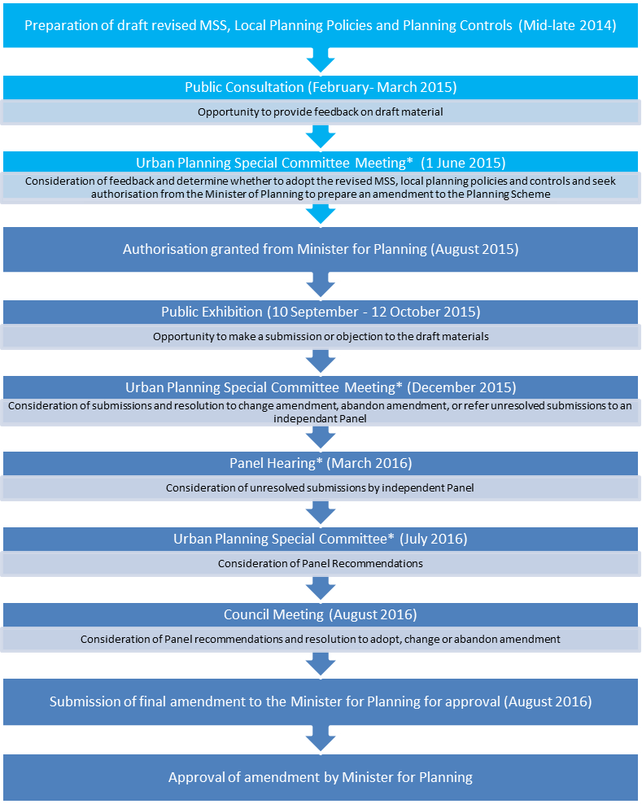
Pre- Consultation
Planning Scheme Amendment
We are here

