Men’s shed survey 2014 - results summary

October 2014

Table of contents
1. Sample 3
2. Findings 3
2.1. Awareness 3
2.2. Benefits 4
2.3. Barriers 4
2.4. Vision 5
3. Other literature relevant to the findings 9
3.1. Awareness 9
3.2. Benefits 9
3.3. Reasons for attending 10
3.4. Barriers 10
3.5. Vision 11
3.6. Inclusivity 12
4. References 13

Men’s shed survey 2014 - results summary

Sample
A sample of 132 people completed the men’s shed survey. This number included 106 members of the Boroondara Community Voice Panel and 26 others. Of the 132 respondents, 127 (96%) had heard of the men’s shed concept.

The Boroondara Community Voice Panel is a group of people with an interest in Boroondara who are regularly asked by Council for their opinion on matters affecting local issues. Because Boroondara Community Voice Panel members have ‘self-selected’ to comment on Council plans and projects they may tend to have a greater awareness of community initiatives, such as men’s sheds, than the broader Boroondara community.

Non-Voice respondents (that is, those who elected to do the survey after reading an article in the Boroondara Bulletin) are also ‘self-selected’. All Non-Voice respondents had heard of the men’s shed concept, suggesting that perhaps their interest in men’s sheds may be what attracted them to do the survey.

The self-selected nature of the survey sample means that the results may not necessarily be representative of the views of the broader community.
Of the 50 respondents who provided their postcode of residence, 98% reported a Boroondara postcode.

Table 1: Postcode of residence, Men’s shed survey sample (n=50)
Postcode | Count
3124 (Camberwell) | 9
3146 (Glen Iris) | 7
3147 (Ashburton) | 7
3122 (Hawthorn) | 6
3103 (Balwyn) | 4
3104 (Balwyn North) | 4
3123 (Hawthorn East) | 4
3127 (Surrey Hills) | 3
3101 (Kew) | 3
3102 (Kew East) | 2
3004 (Melbourne) | 1
Total | 50

Findings

Awareness
There are three men’s sheds open to the public in Boroondara (in Kew, Hawthorn and Ashburton), but only 48% of respondents were aware of a local men’s shed.
Of those who were aware of a local men’s shed, only 15% reported that they had been a men’s shed user or member in the past. The men’s sheds listed were Alamein (three respondents), Kew, Elgin Street and Samarinda (one respondent each) and four located outside Boroondara.

Benefits
Respondents were asked to select what from a list of 10 benefits men might gain from men’s sheds or activities for men. Respondents to this question each chose between one and 10 benefits. Figure 1 shows the results.

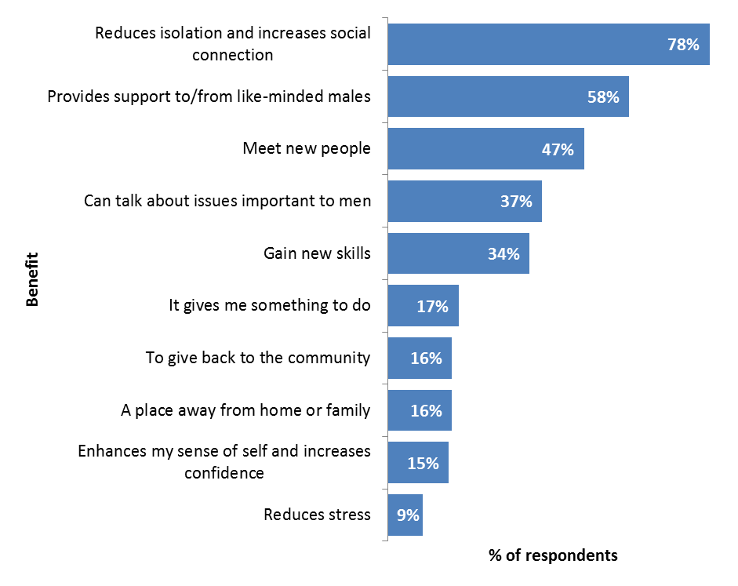

Figure 1: Responses to ‘What do you think are the main benefits men gain from using men’s sheds, or programs or activities that are designed specifically for men?’ (n=129)

Other benefits put forward by respondents were:
- builds community connections
- chance to pass on new skills to others
- have fun
- it could give me access to tools I don't have
- share resources such as tools and skills.

Barriers
Respondents were asked to select from a list of 10 barriers what might prevent men from going to a men’s shed. Respondents to this question each chose between one and five barriers. Figure 2 shows the results.
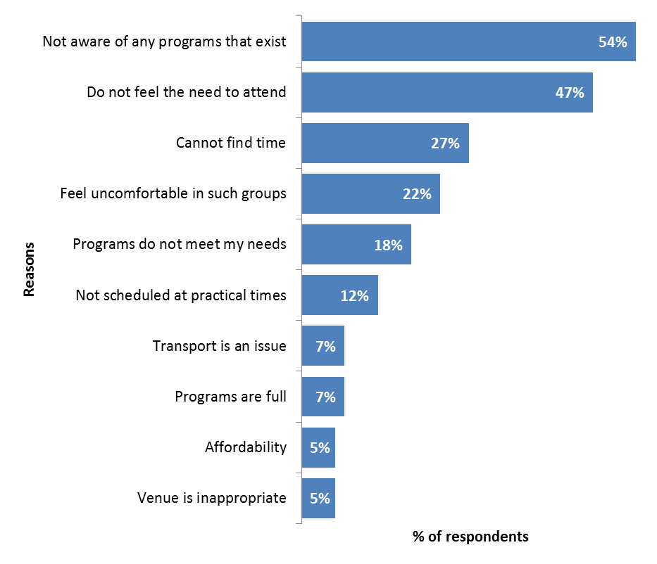
Figure 2: Responses to ‘What are the reasons that prevent you, or a male in your life from going to a men’s shed?’ (n=129)

Some of the other reasons put forward by respondents were:
- the programs are for older men (and I/the males in my life are too young)
- stigma (seen as an “old man’s” activity or for people who have “social problems”)
- uncertainty about what happens at a men’s shed
- not confident of being accepted (due to dementia, language/cultural differences, gender identity)
- nothing “male run and male led”
- just haven’t thought about it/too lazy
- don’t have the skills
- too far away
- health/mobility.

Vision
Figure 3 shows the top 100 words used in responses relating to respondents’ vision for a welcoming, engaging and relevant men’s shed. Larger words were used more frequently.
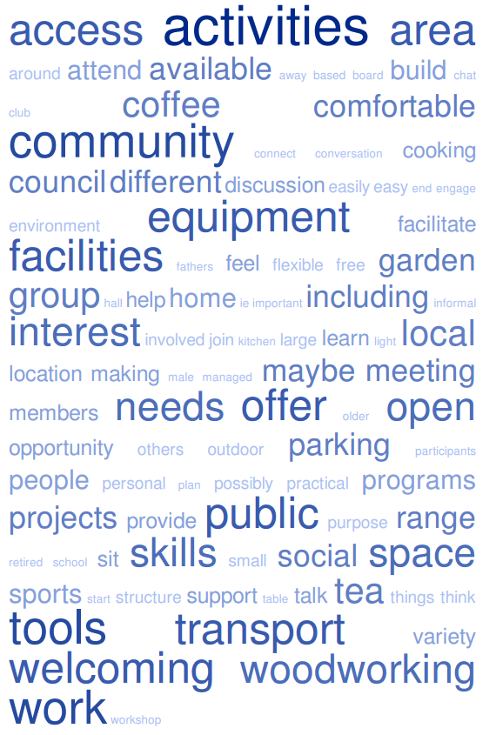
Figure 3: Word cloud for responses to the question ‘If you were to design a men’s shed that is welcoming, engaging and relevant for men, can you describe what that would look like? What would it offer? Where would it be?’(n=110, excludes “I don’t know” responses)

One-hundred and ten people shared what a welcoming, engaging and relevant men’s shed would look like, what it would offer, or where it would be. These responses were examined to identify reoccurring themes. The below is not a comprehensive account of all the responses received, but summarises ideas that were communicated frequently within the responses.

Friendly and welcoming. Many respondents paraphrased the question to emphasise that the space must be welcoming and friendly.
“The place should be attractive and welcoming”
“It would be a welcoming place where everyone who visited felt valued in what they could contribute”
“a friendly place that men can go…”
More than a shed. While many respondents highlighted the importance of the more traditional men’s shed offerings (for example, a workshop space with access to a range of tools), many described other elements important to making a men’s shed appealing, including:
- a comfortable area to sit and socialise
- tea and coffee making facilities (and biscuits or other food) at low cost or for free
- a kitchenette
“A hall with a kitchenette at one end and workshop at the other. Have a table to sit around”
- cooling and heating. The word “warm” was used many times, although often it was not clear whether the reference was literal or figurative.
- good lighting
- a garden and/or outdoor space “for a BBQ”
- books.
More than woodwork. Many respondents’ vision included activities other than woodwork or metalwork. Several also suggested that gardening and cooking should be offered. Board games and televised sports were also mentioned.
“A place to build, cook, chat and garden”
A few respondents suggested offering activities or courses in fields that do not involve manual skills (for example, internet or computers).

Provides purpose. The term ‘purpose’ and/or an opportunity to work on community projects was described by several respondents.
“set up an ongoing project to create toys for children at Christmas”
Inclusive. Several respondents reported that a men’s shed should cater to a range of abilities (including beginners) and should be welcoming to young men as well as older men. Other groups described as needing to be welcomed were attendees from different cultural backgrounds and people of diverse sexual orientation/gender identities.

Flexible. Many respondents thought a men’s shed should have long opening hours to allow people with other commitments to attend at flexible times.

Some respondents highlighted the importance of being able to attend if and when they choose, with no commitment, while others reported that a men’s should offer structured programs or projects.

Several people suggested that the programming should be determined based on the preferences of the attendees or members of the shed.

A place to talk. There were some mixed opinions on the degree of emphasis that should be placed on talking. Most people who mentioned it, reported that it was important for a men’s shed to promote social interaction by providing a comfortable seating space or providing attendees with a shared activity or task to perform while chatting.
“Simply a place to talk to like-minded people”
Some people thought opportunities to talk about personal issues were important, while others reported that they would find a targeted social support element off-putting.

An opportunity to learn and share. Several respondents reported that a men’s shed should provide an opportunity to learn new “practical and other” skills, while others would welcome an opportunity to share their skills with others.

Several respondents mentioned training, courses or seminars but others appeared to be referring more to an informal sharing of skills or mentoring.

Accessible (location). Several respondents reported that it would be important for the shed to be near where they live. Other ideas about location included:
- close to public transport
- good parking
- at an existing community hub or facility
- “semi industrial areas or commercial areas where they feel more comfortable in the surrounds. Not a local neighbourhood centre”
- at primary schools
- sports hall/pavilion
- a shop front on a main road.
Some respondents thought men’s sheds should not be “hidden away” while others thought men’s sheds should offer a level of privacy for attendees.

Accessible (information). Advertising and promotion, including online, is important to give men’s sheds a higher profile in the community and prevent the need for potential attendees to “cold call”.

Facilitated. Many respondents suggested that a men’s shed should be attended by a person in an official capacity. The exact nature of this role was described differently by respondents. Descriptions included:
- facilitator
- host (to “meet and greet”)
- mentor
- trainer
- instructor
- professional
- local or external enthusiasts/experts
- guest speaker.
Well managed. The importance of good quality management of the shed was flagged by several respondents.

Other literature relevant to the findings
In 2013, the City of Wollongong (on the NSW coast, about 80 kilometres south of the Sydney CBD) administered similar questions to those included in the Boroondara men’s shed survey to 346 of their residents.

Also in 2013, Beyond Blue investigated the potential health benefits of men’s sheds in Australia using interviews, focus groups and over 2,500 surveys.

A brief review of the results of the Wollongong and Beyond Blue studies provides further insights and context in which to interpret survey findings.

Awareness
The City of Wollongong survey revealed that 88% of residents were aware of the men’s shed concept. This is lower, although not substantially, than the 96% of Boroondara respondents who reported being aware of the men’s shed concept.

This difference may be due to different sampling methods between the Boroondara and Wollongong surveys, or real differences in awareness levels.

Wollongong is approximately 12 times the area of Boroondara (and 1.2 times the population) but has only three times the number of men’s sheds (10).

Benefits
The Victorian Department of Human Services (2013) recognises the following benefits of men’s sheds:
- enable older men to remain independent, active and healthy
- support social connectedness through improved self-esteem, confidence, physical and mental health for vulnerable men
- strengthen local communities by engaging men in volunteering, working with and mentoring others
- create pathways to further education, training and employment.
The Beyond Blue (2013) research confirmed many of these benefits.

The Wollongong survey revealed a similar picture to that provided by the Boroondara survey in terms of the rankings of the various perceived benefits, with the top two benefits being the same. Boroondara residents were more likely than Wollongong residents to report these two benefits however. Table 2 shows Wollongong results on this question.

Similar to the Boroondara and Wollongong surveys, the Beyond Blue study showed that the most often reported perceived benefits of participation in a men’s shed are ‘socialising and getting out’ and ‘making new friends’.

Table 2: Wollongong residents’ perceived benefits of being involved in a men’s shed
Benefit | % of respondents
Reduces isolation and increases social connection | 62%
Provides support to/from like-minded males | 40%
Can talk about issues important to men | 37%
Meet new people | 35%
It gives them something to do | 32%
Gain new skills | 26%
To give back to the community | 25%
A place away from home or family | 21%
Increases confidence | 20%
Reduces stress | 19%
Other | 12%

Reasons for attending
Beyond Blue (2013) reports that focus groups revealed that many members had come to their men’s shed when looking for a way to adapt to changes which impacted significantly on their relationships, such as:
- retirement or job-loss
- a change in family circumstances such as the loss of a spouse or divorce
- a health issue
- relocation to a new area.
‘To meet new friends’ was the top reason for joining a men’s shed in the Beyond Blue research, but ‘to give back to the community’ came a close second. The Boroondara survey did not include a question about reasons for joining (as the sample were not necessarily men’s shed members) but showed that only 16% of respondents thought that ‘to give back to the community’ would be a benefit of joining a men’s shed. The notion that a shed should provide an opportunity to give back to the community did however emerge during the open feedback about what a shed should be.

The Beyond Blue report suggests that there is often a gradual shift in the reasons for attending a men’s shed over time, with reasons for initial attendance tending to centre around socialising, and then shifting toward giving back to the community (for continued attendance).

“The long term nature of Shed membership is found to be very meaningful. Over time, the shed’s main purpose is recognised to be largely related to more intangible benefits, for example personal fulfilment, through helping and
caring for others.” Beyond Blue 2013, p. 11.

Barriers
Wollongong residents were asked to provide comment on their reasons for not being involved in men's sheds. A summary of responses is presented in Table 3, which shows that the same proportion of respondents (54%) in Boroondara and Wollongong reported that the main reason men might not access men’s sheds is that they don’t know about them.
Compared to the Wollongong sample, the Boroondara sample were considerably more likely to report not feeling a need to attend and less likely to report feeling uncomfortable in such groups or that transport is an issue.

Table 3: Wollongong residents reasons for not being involved in a men’s shed
Reasons for not being involved | Percentage
Not aware of any programs that exist | 54%
Feel uncomfortable in such groups | 40%
Do not feel the need to attend such things | 35%
Transportation is an issue | 25%
Programs do not meet their needs | 23%
Cannot find time | 17%
Other | 17%
Programs are full | 13%
Not scheduled at practical times | 12%
Cost | 9%
Venue is inappropriate | 9%

Vision
Wollongong residents were asked to complete the statement “For men to feel comfortable and happy to attend a shed or space, it would need …”. In contrast, Boroondara residents were asked to describe a welcoming, engaging and relevant men’s shed. Nonetheless, many of the responses overlap. Summary results from the Wollongong study are presented in Table 4. Themes which also emerged in Boroondara are presented in bold.

Table 4: Wollongong residents’ top responses to “For men to feel comfortable and happy to attend a shed or space, it would need …” (source: Wollongong City Council 2013, p. 10)
Physical facility | Centrally or well located; easy to access; close to public transport; cycleways and parking
Physical facility | Supplied with tea and coffee; biscuits
Physical facility | A workshop environment with tools available (ones not available at home and in good condition)
Physical facility | Offer tables, seating, couches (not too low)
Physical facility | Provide different spaces for different activities e.g. relax/quiet zone and workshop space
Programs and activities | Offer a variety of activities; suitable for all skill levels
Programs and activities | Activities are meaningful and engaging; purposeful; practical
Programs and activities | A place to learn new skills and share your skills (eg DIY classes)
Programs and activities | Availability of books, newspapers and space for reading
Programs and activities | Gardening activities
Programs and activities | Arrange specific topics/talks for men
Qualities | Friendly; welcoming; non-threatening. “It's not the space, but the men that make up that space that counts”
Qualities | A place for connection and socialising; meeting new people
Qualities | An informal, relaxed environment. Not too many rules; non-competitive; no pressure to "do" anything; a lack of performance criteria
Qualities | A place where men feel useful, valued and needed. Where men are part of a team and can contribute to project ideas
Qualities | A safe (OHS) environment; clean and tidy

Inclusivity
The need for men’s sheds to be inclusive was mentioned by several participants in the Boroondara survey. The Beyond Blue research suggests that men’s shed membership in Australia is:
- 80% men who have retired from paid work (and has an average age of 67 years)
- 22% men born overseas
- 6% men who speak a language other than English at home
- 96% identify as heterosexual.
These figures suggest an under-representation (in terms of the male population of Australia) of younger men (the average age of Australian men is 37 years), men who speak a language other than English at home (18% of Australian men). The under-representation of men born overseas, who make up about 24% of the Australian male population, was less pronounced. However, given the under-representation of non-English speaking men, it may be that some countries of birth are in fact under-represented (while others are over-represented). Representation of men who are not heterosexual (an estimated 2.5% of Australian men, Australian Research Centre in Sex, Health & Society 2003) may be at levels concordant with the broader population.

References
Australian Research Centre in Sex, Health & Society 2003, Sex in Australia: Summary findings of the Australian study of health and relationships, Australian & NZ Journal of Public Health, Vol 27 No 2.

Beyond Blue 2013, Men’s sheds in Australia: effects on physical health and mental wellbeing, viewed 25 June at http://www.beyondblue.org.au/resources/research/research-projects/research-projects/men-s-sheds-in-australia

Victorian Department of Human Services 2013, Strengthening Men’s Sheds Program; Guidelines for applying for grants to build new Men’s Sheds, viewed 25 June 2014 at http://www.dhs.vic.gov.au/for-business-and-community/community-involvement/men-in-the-community/strengthening-mens-sheds

Wollongong City Council 2013, Men’s Spaces & Places: Community Engagement Report, viewed 26 June 2014 at http://www.wollongong.nsw.gov.au/services/community/Pages/mensplaces.aspx

